**Functional and aesthetic outcomes of no dissection nasal dorsum using sub dorsal Septal Excision in preservation rhinoplasty**

**Authors:**

**Kurdo Akram Qaradaxi:** Department of Surgery, College of Medicine, University of Duhok, DUHOK, Kurdistan Region, Iraq.

.

**Functional and aesthetic outcomes of no dissection nasal dorsum using sub dorsal Septal Excision in preservation rhinoplasty**

**Abstract:**

**Background:** Dorsal preservation cause privileges change in the concept of rhinoplasty and a promising superior functional and aesthetic transformation in rhinoplasty surgery. Avoiding dissection of the dorsal nasal bone and cartilage will leave the soft tissue enveloped intact leading to a fine and smooth appearance, faster operation with less subsequent edema, and overall preservation of the dorsal aesthetic line.

**Patients and methods:** This is a prospective study which included 113 patients who underwent dorsal preservation rhinoplasty for nasal hump treatment with minimum dissection of nasal dorsum soft tissue envelope were included and results were evaluated using the Standardized Cosmesis and Health Nasal Outcomes Survey (SCHNOS).

**Results:** The mean preoperative SCHNOS score was 7.21, the mean obstructive score was 2.95 (SD: 1.068) and the mean aesthetic score was 4.27 (SD: 0.771). The average lowering of the dorsal hump was 4.4 mm. About 96% of the patients showed improvement in the SCHOZ score after surgery, 86.7 % of patients (98 patients) showed improvement in the obstructive symptoms and 95.6% of them (108 patients) showed improvement in the aesthetic score. Complications seen in 22.11%, most commonly residual hump in 13.27% of the cases and dorsal indentation in 5.31%, bleeding and granuloma formation at the dorsal osteotomy site constituted 2.65% and 0.88% respectively. There was a very significant improvement in the aesthetic, obstructive, and the overall SCHNOS score (P values 0.000) for each parameter.

**Conclusion:** Dorsal preservation rhinoplasty is safe and very effective procedure, with very low risk of complications. The majority of patients have improvement of the obstructive and aesthetic outcome after surgery.

**Introduction:**

Dorsal preservation (DP) caused privileges change in the concept of rhinoplasty and a promising superior functional and aesthetic transformation in rhinoplasty surgery. Nasal hump treatment with preservation of the dorsum goes back to Lothrop in 1914 and the term was first described by Daniel in 2018. The main idea behind the DP is that the usual standard technique of reduce and rebuild is replaced with preserve and reshape the nose. The classical structural rhinoplasty has evolved when surgeons noticed that when the nasal anatomy is changed or made smaller, these structures must be rebuilt and again to resist the forces of scar contracture. If anatomy is preserved still structural rebuilding will be required but to lesser extent. [1-6]

Preservation rhinoplasty involves 3 major steps to perform the surgery; these include elevation of the soft tissue enveloped via sub-perichondrially and the sub-peirosteally approach, preservation of the osteo-cartilaginous dorsum, and maintenance of the alar cartilages with minimum resection. Most surgeries for rhinoplasty involve resection of the dorsal hump resulting in the creation of an open roof which require osteotomy and reconstruction of the mid-vault with upper lateral cartilage tension spanning suture to reconstitute the upper lateral cartilages into the normal anatomical position, spreader flaps, or spreader grafts, while dorsal preservation surgery aims to maintains the dorsal structures and it eliminates the dorsal hump through sub-dorsal septal resection which is followed by osteotomy to decrease the height of the dorsal line. By this technique the surgeon is able to modify the nasal dorsum without major destruction of the nasal anatomy with maintaining the dorsal aesthetic line. [1, 7]

The Standardized Cosmesis and Health Nasal Outcomes Survey (SCHNOS) for functional and cosmetic rhinoplasty scale is a recently introduced, validated, multimodal patient-reported outcome that measures the patient’s perception of their nasal appearance and nasal function and its impact on social performance, it is more specific more inclusive and has been the most extensively validated. The Standardized Cosmesis and Health Nasal Outcomes Survey (SCHNOS) is the first patient-reported surgery outcome that is developed adopting the accepted international standards for evaluation of both functional and cosmetic components of rhinoplasty surgery. This include a standard questionnaire that contain 10-item self-reported questions concerning the functional and the aesthetic points before rhinoplasty surgery and reporting the outcomes after that. [8-13]

The aim of this study is to explore the natural history of both domains of the SCHNOS questionnaire after functional, cosmetic, and the combined (functional and cosmetic) outcomes in preservative rhinoplasty over 15 months follow-up.

**Patients and methods:**

This is a prospective study which was conducted in the period between November 2018 and March 2020. A total number of 113 patients who underwent dorsal preservation rhinoplasty for nasal hump treatment with minimum dissection of nasal dorsum soft tissue envelope were included. Patients with genetic or congenital facial disorders, patients who had previously undergone hump treatment, those who require mid vault reconstruction, and those with sever nasal septal deviation were excluded from this study.

The dorsal deformity was ordered depending on the anticipated amount of dorsal reduction and the dorsal shape using Goran D. Lazovic classification. [14]

We determined the anticipated amount of dorsal hump reduction by photo imaging using profile photos of the cases. The nasal hump is either V or S shape, when the caudal portion of the nasal bones is straight from nasion (N point) to keystone junction (R point) without angulation, this will result in a “V-shape” configuration, while cases that have distinct kyphion point (K point) and kyphion angulation result in an “S-shape” nasal bone configuration, we put single septal piece to augment dorsal area cephalic to supra tip breaking point.

**Surgical technique:** All operations were performed under general anesthesia, regardless adopting an open or closed approach, we used sub-dorsal septal excision (Saban sub-dorsal strip technique) and the nasal dorsum was not undermined in all cases. Figure 1.

**Figure 1: Schematic representation of the sub-dorsal excision of septum, starting from M point.**

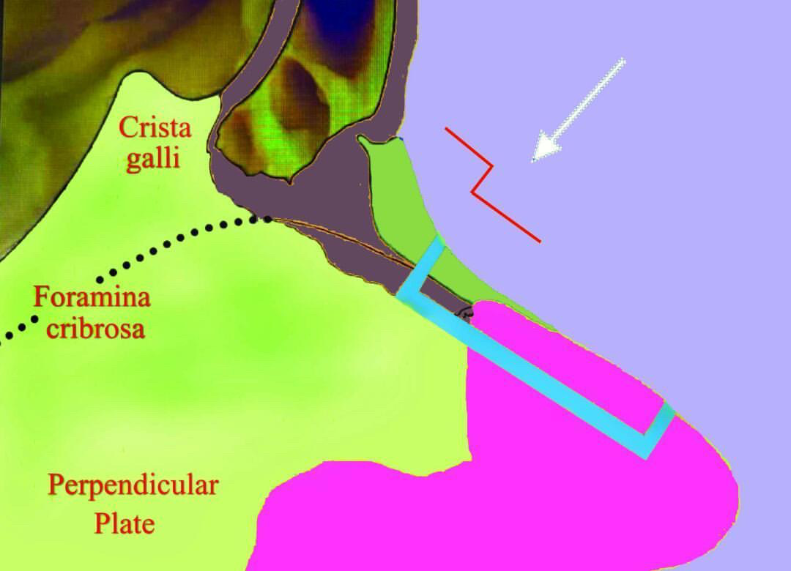

In case of open approach, the surgery started with transcolumellar incision until we reached the tip and then we cut only the superficial pitanguys ligament and stopped there leaving deep pitanguys ligament intact. Figure2.

**Figure 2: an intraoperative picture showing opening tip and stopping the dissection there leaving the deep midline pitanguy ligament and lateral scroll area intact.**

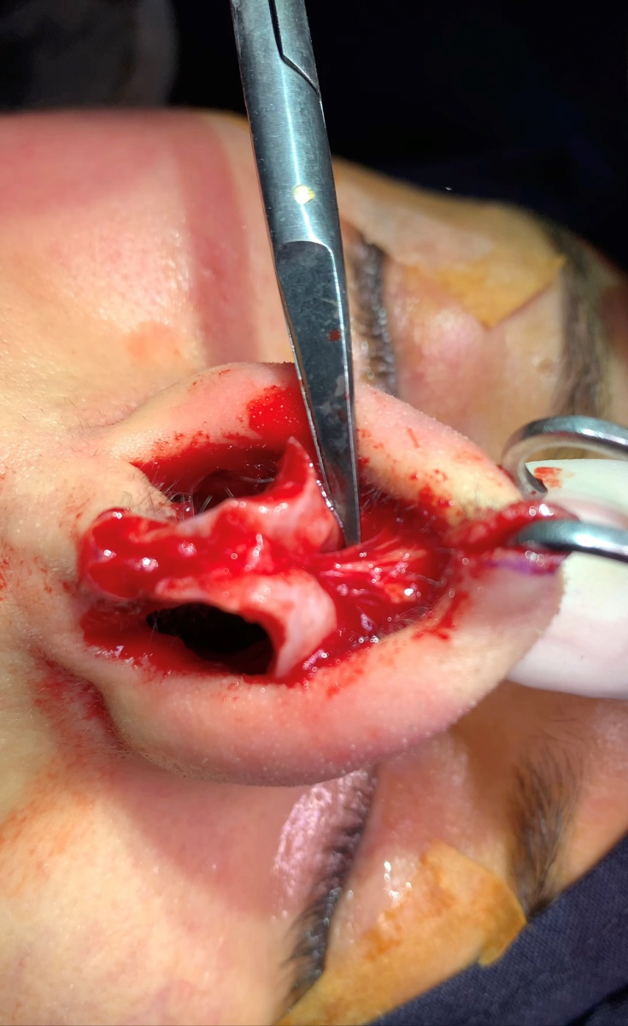

A hemi-transfixion incision is then made leaving 1mm of the caudal septal cartilage untouched this is regarded as a posterior strut preserving the midline pitanguy ligament coming from dorsum attachment to the nasal septum spine, then the posterior septum is undermined in a sub-perichondrial plane on both sides, after complete septum dissection Saban sub-dorsal septal excision is performed without disrupting the M-shaped connection between the ULC (lateral process). In cases who required septoplasty after or required harvesting of the septal cartilage for graft, we removed the lower septal area leaving not less than 20 mm as L - shaped septum behind to support the nose.

Initially a conservative resection is done using a baby Rongeur and multiple small bites are removed, this will avoid any twisting motion, then an incremental excision is done. Lateral nasal osteotomy is done via internal or external chisel, transverse fractures when present ahead of the dorsal hump, a transcutaneous access may be chosen with a 2-3 mm thick angled osteotome, it should be an oblique transverse fracture. Push down is perform if dorsal lowering is less than 4mm, while let down is performed for greater lowering .i.e. in the range of 5- 14 mm. Figure 3.

**Figure 3: A schematic picture showing the direction of push down which is perform when the dorsal lowering is less than 4mm, while let down performed for greater lowering (5- 14 mm).**

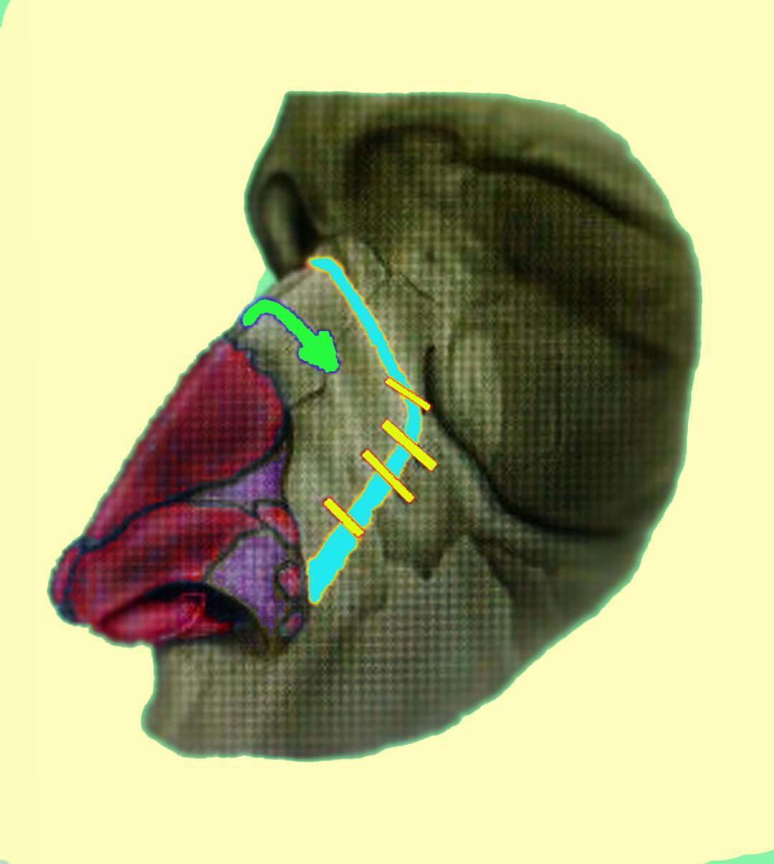

In some patients with deviated nasal septum, it may be necessary to remove the horizontal septal cartilage with the maxillary crest. It is important to clarify that the osteo-cartilaginous parts can be removed en block if both have deviation paying particular attention to remove a sufficient amount to lower the dorsum with no fluctuation. In cases of deviated nose and when there is bony asymmetry, more bone pieces are removed from the larger lateral nose starting from Webster region. Figure 4.

**Figure 4: In case of deviated nose more bone is excised starting for webinar triangle from the more deviated side.**

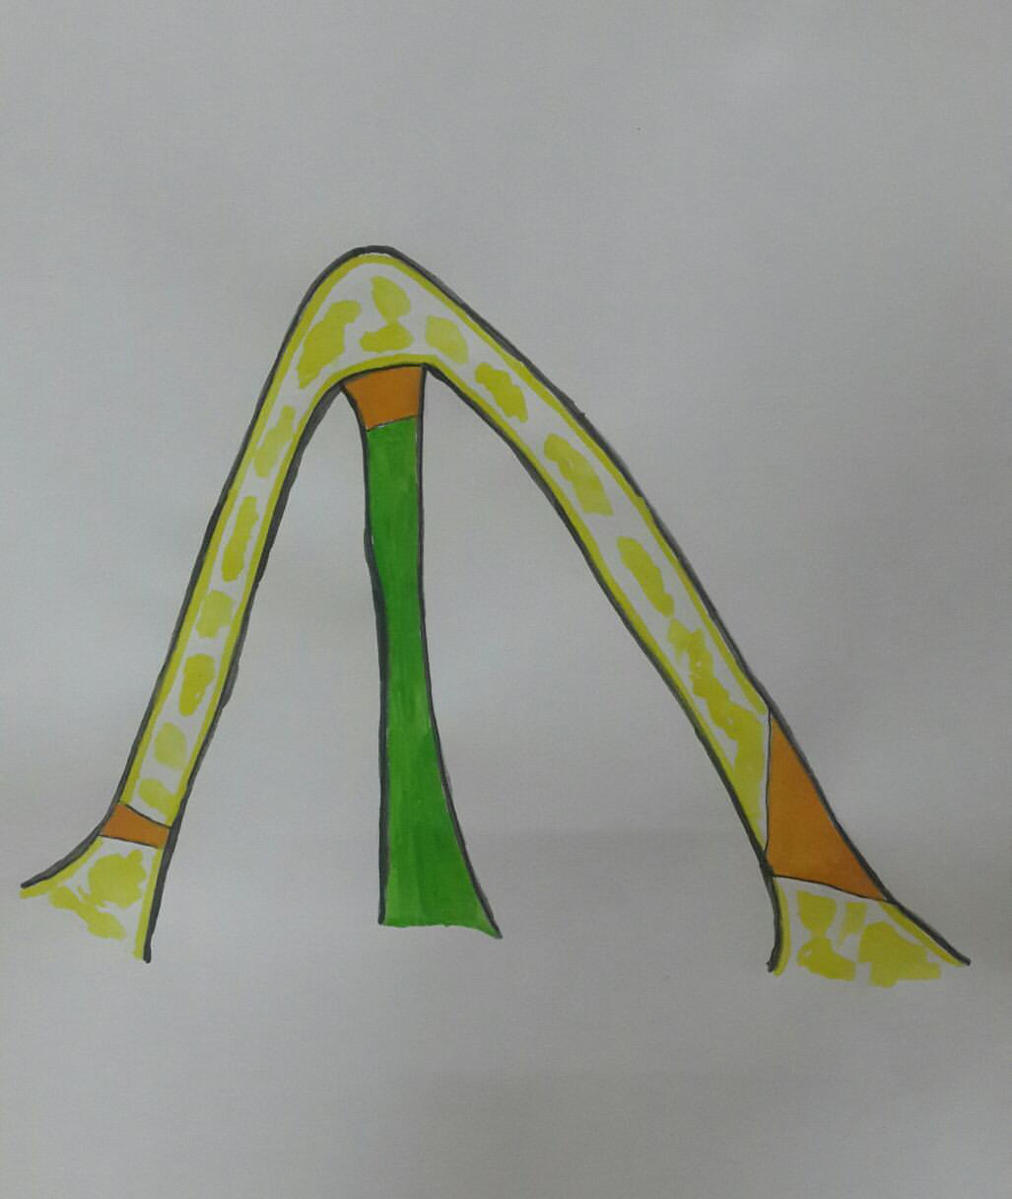

In cases of S-shaped dorsum certain extra maneuvers are essential to prevent spring recurrence of dorsum like making sure that adequate bony septum is removed, multiple incision (scoring) are done in the sub-dorsal septum, proper fixation of dorsum to the septum by suturing the lateral keystone area (bone cartilage split) or what is called ballerina manoeuver. I addition we usually place a 5-9 mm septal piece cephalic to supra-tip point to avoid saddling at that critical area in patients with S-shaped dorsum. Some adjustments may be necessary like reduction of alae and internal nasal splints.

Surgery on the remaining tip is carried out according to the surgeon’s preference, internal nasal splinting is left in place, and the cast and splint is removed after 7-9 days. The specific postoperative restrictions for this procedure are not different from conventional rhinoplasty.

Patients were examined at day 9, 12 weeks and 15 months after surgery with physical examination and/or photographs and the results were documented for evaluation. We reported the functional and cosmetic analysis preoperatively via Standardized Cosmesis and Health Nasal Outcomes Survey (SCHNOS) for functional and cosmetic purposes. Figure 5.

**Figure 5: Pictures of 2 patients who underwent preservation rhinoplasty before and after surgery.**

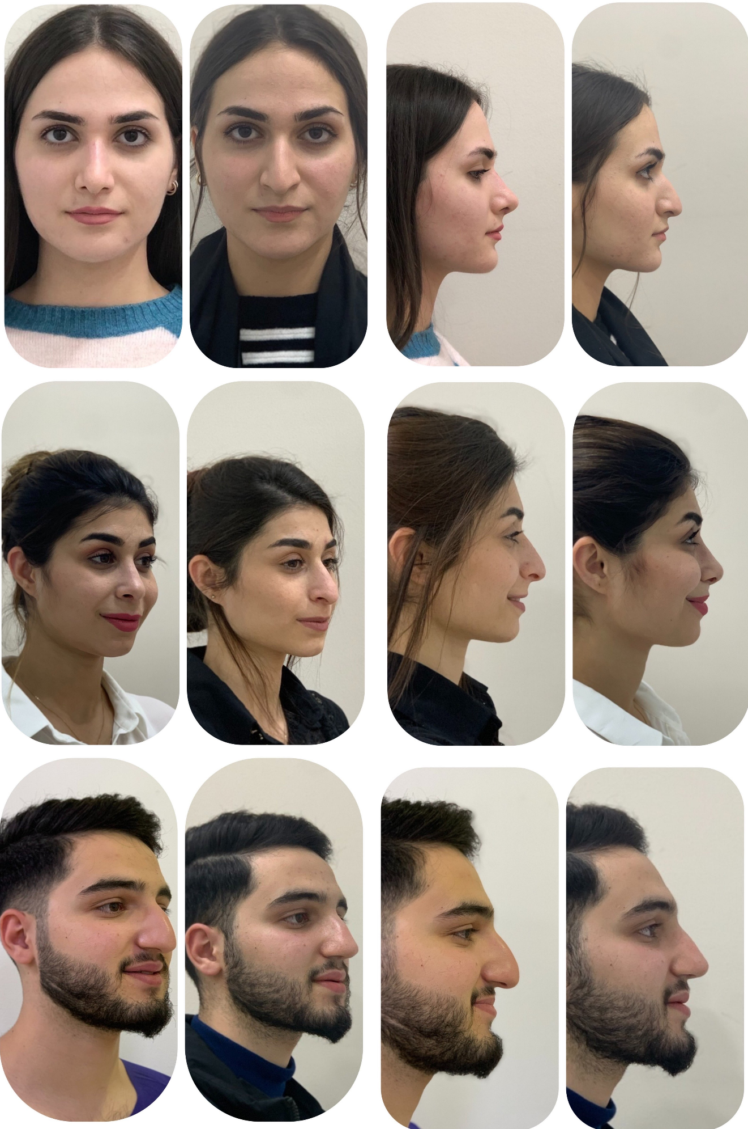

**Statistical analyses:** Statistical analyses described in frequencies for categorical variables and means and standard deviation for numerical variables, and correlations are made using the P value, values equal or less than 0.05 were considered significant. Data are analyzed using the Statistical Package for Social Science (SPSS) version 25.

**Ethics and registration:** This study was approved by the Ethical Committee and Research Registration of Duhok medical college. An informed written consent was taken from each patient to be enrolled in the current study.

**Results:**

The mean age of the patients involved in this study was 27.98 years, females constituted about 61.1%, and most of the involved patients had S-shaped dorsal nasal hump. The mean preoperative SCHNOS score for obstructive symptoms was 3 and the mean preoperative SCHNOS score for aesthetic score was 2.95. Table 1.

**Table 1: Shwoing the general characteristics of the involvd patients.**

|  |  |  |  |
| --- | --- | --- | --- |
| Main category | Subcategories | Frequency | Percentage |
| Age (M;SD)  Range: 18-24 |  | 27.98 | 11.195 |
| Gender | Male  Female | 44  69 | 38.9  61.1 |
| Type of dorsal hump | V-shaped  S-shaped | 28  85 | 24.8  75.2 |
| Pre-operative SCHNOS (M;SD)  Range: 2-10 | 7.21 |  | 1.515 |
| Pre-operative SCHNOS (Obstructive symptoms), (M;SD)  Range: 1-5 |  | 3 | 1.068 |
| Pre-operative SCHNOS (Obstructive symptoms) | 1  2  3  4  5 | 10  26  48  18  11 | 8.8  23.0  42.5  15.9  9.7 |
| Pre-operative SCHNOS score (Obstructive symptoms), (M;SD)  Range: 1-5 |  | 2.95 | 1.068 |
| Pre-operative SCHNOS score (Aesthetic score) | 2  3  4  5 | 3  13  47  50 | 2.7  11.5  41.6  44.2 |
| Pre-operative SCHNOS (Aesthetic score) (M;SD)  Range: 2-5 |  | 4.27 | .771 |

The mean operation time was 132.85 minutes, the mean lowering of the dorsal nasal hump was 4.4 mm. Postoperative SCHNOS improved after surgeries, with a mean of 3.04, with mean obstructive score of 1.49 and mean aesthetic score of 1.6. Table 2.

**Table 2: Showing some of the operative and the postoperative information.**

|  |  |  |  |
| --- | --- | --- | --- |
| Main category | Subcategories | Frequency | Percentage |
| Operation time (minutes), (M;SD)  Range: 100-167 minutes |  | 132.85 | 14.528 |
| Lowering the dorsal hump (mm), (M;SD)  Range: 1-7 mm |  | 4.40 | 1.386 |
| Post-operative SCHNOS  Range: 0-8 |  | 3.04 | 1.695 |
| Post-operative SCHNOS (Obstructive symptoms), (M;SD)  Range: 0-4 |  | 1.49 | 0.857 |
| Post-operative SCHNOS scores(Obstructive symptoms) | 0  1  2  3  4 | 11  50  40  10  2 | 9.7  44.2  35.4  8.8  1.8 |
| Post-operative SCHNOS (Aesthetic score)  Range: 0-5 |  | 1.60 | 1.065 |
| Post-operative SCHNOS scores (Aesthetic score) | 0  1  2  3  4  5 | 15  43  33  17  4  1 | 13.3  38.1  29.2  15.0  3.5  .9 |
| Post-operative obstructive symptoms | Improved  No improvement | 98  15 | 86.7  13.3 |
| Post-operative aesthetic score | Improved  No improvement | 108  5 | 95.6  4.4 |

The majority of the patients involved in the current study developed no complications (77.88%), however some patients developed complications such as residual hump, dorsal indentation, bleeding and granuloma at dorsal osteotomy site. The bleeding was minor in all the cases. Figure. 1

**Figure 6: A simple bar chart showing theh rate of the compications of our patients.**

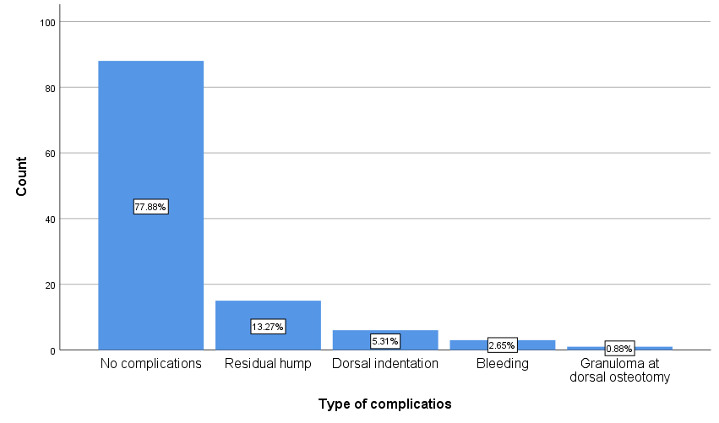

Correlations were made between the preoperative and the postoperative SCHNOS scores, and between each of the obstructive and the aesthetic scores before and after surgery. All the correlations were very significant with P values 0.000. Table 3.

**Table 3: Showing the correlations between the preooperative and postoperative SCHNOS scores.**

|  |  |  |  |  |  |
| --- | --- | --- | --- | --- | --- |
| Category | Std. Deviation | Std. Error Mean | 95% Confidence Interval of the Difference | | Sig.  (2-tailed) |
| Lower | Upper |
| Pre vs. post-operative SCHNOS score (Obstructive symptoms) | 1.188 | .112 | 1.239 | 1.682 | 0.000 |
| Pre vs. post-operative SCHNOS score  (Aesthetic score) | 1.235 | .116 | 2.442 | 2.903 | 0.000 |
| Pre-operative vs. Post-operative SCHNOS | 2.050 | .193 | 3.795 | 4.559 | 0.000 |

**Figure 7: A simple bar chart showing the overall outcome after surgery.**

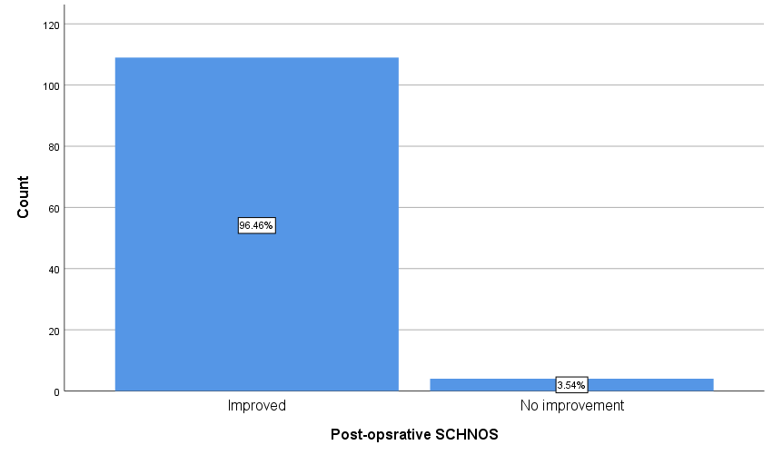

**Discussion:**

Traditionally, rhinoplasty involve elevation of soft tissue envelope in either a subcutaneous or sub-superficial musculoaponeurotic system (SMAS) plane because it is relatively avascular and causes less disruption the subcutaneous plane, but still it is associated with variable degrees of postoperative edema, numbness, long period of scar remodeling, and induration. Long-term thinning of the soft tissue envelope (STE) is a major concern, elevation of the soft tissue envelope with a continuous subperiochondrial-subperiosteal dissection causes minimum edema, better sensation, minimum remodeling of the scar, and minimum long term thinning of the STE. Elevating the STE as a single sheet is crucial to minimize both short and long term complications. But on the other hand, it require experience, meticulous technique, sometime skin surface irregularities and require newly instruments. [15]

Many of the young rhinoplasty surgeons are not familiar with the concept of nasal dorsum preservation (namely the push-down and let-down techniques) and the major difference of it from the resection rhinoplasty. The essential goals of the push down technique are maintain preservation of keystone area and continuity of the cartilaginous vault with septum who shared same embryological origin as same unite, thus preservation technique prevents collapse of the nasal valve which enhance the function and has adverse effects on the dorsal aesthetic lines, lowering the cartilaginous vault intact in the push down technique will result in a vertical vector downward on the scroll area junction between the upper and lower lateral cartilages resulting in a cephalic rotation of the lower lateral cartilages. [1, 16]

In our study, patients having S-shaped deformity constituted the majority of the patients (75.2%). The mean preoperative SHNOS score was 7.21 (SD: 1.515), the mean obstructive score was 2.95 (SD: 1.068) and the mean aesthetic score was 4.27 (SD: 0.771), this signifies that most patients seeks surgical intervention because of cosmetic considerations. The improvement of the nasal appearance have been shown by many authors to be associated with a dramatic improvement in the functional outcome. [17, 18]

The ability to avoid skin undermining eliminate the requirement for fascia grafts and lead to fine smooth appearance, faster operation with less edema subsequently the dorsal aesthetic line will be more preserved ,risk of long term thinning and also decrease the risk of dorsal deformity. No skin undermining of the dorsum is performed when patients have a V-shaped dorsum with minimal or no hump. A high sub-dorsal septal strip is removed and osteotomies are performed with an osteotome adopting an external approach to release the osteo-cartilaginous vault from the mid face. In cases of S-shaped dorsum certain extra maneuvers are essential to prevent spring recurrence of dorsum like making sure that adequate bony septum is removed, multiple incisions (scoring) are done in the sub-dorsal septum, proper fixation of dorsum using 4/0 PDS suture to the septum, and release of the lateral keystone area. This maneuver should be subtle, typically 3-4mm, which means that one never detaches completely the entire relation of the upper lateral cartilages (ULCs) and the lateral keystone area (bone cartilage split). Generally for 1 mm lowering dorsum, there should be 1 mm of sub-dorsal septal excision. In cases of S-shaped dorsum, we usually place a 5-9 mm septal piece cephalic to supra tip point to avoid saddling at that critical area through small tunnel on the side of deep pitanguy ligament, harvested from lower part of septum leaving minimally 20 mm L- strut septum. [19]

The average lowering of the dorsal hump in our patients was 4.4 mm (SD: 1.386), this is regarded as acceptable when compared to other published articles, and some articles reported a similar results although the technique is new and future studies are still required. About 96% of the patients who were involved in our study showed improvement in the SCHOS score after surgery, 86.7 % of patients (98 patients) showed improvement in the obstructive symptoms and 95.6% of them (108 patients) showed improvement in the aesthetic score. Studies reported a lower rate of improvement than our patients. Review of literature supports improvement of the results after surgery in both structural and preservation rhinoplasty and shows high satisfaction score in both. There are no supporting references explaining that dorsal hump has relation to nasal obstruction, so probably is a substantial factor. [4]

Because the technique of preservation rhinoplasty is a new one, more studies must be conducted to further assess and compare the satisfaction score regarding both obstructive and aesthetic scores following preservation rhinoplasty and appropriately comparing rhinoplasty techniques. [20]

The reported complication rate in our study was 22.11%, the most common type of complication was residual hump which was reported in 13.27% of the cases, followed by dorsal indentation in 5.31%, bleeding and granuloma formation at the dorsal osteotomy site constituted 2.65% and 0.88% respectively. Dorsal indentation" or "step off” were faced after the initial surgeries, then we tried to reduce the occurrence of this problem angulating the dorsal osteotomy by 40 degrees to hang it down without step off appearance. There was a very significant improvement in the aesthetic, obstructive, and the overall SCHNOS score after surgery (P values 0.000) for each parameter. The functional complication were related to pre-existing elements of allergic rhinitis in 15 patients, while the aesthetic related complication were minor according to the patients reported outcomes such as minor residual hump or indentation of proximal dorsum. No revisions were necessary for the dorsal preservation cohort and no patients had revision surgery for nasal airway obstruction. Meticulous attention to the details of the operative steps is the major factor to optimize the operative results and decrease the rate of complications and suboptimal results. [21]

**Conclusion:** No dissection nasal dorsum using sub dorsal septal excision in preservation rhinoplasty technique has low risk of major complications. The majority of patients have improvement of the obstructive and aesthetic outcome after surgery. As surgeons continue to develop and employ these techniques, critical assessment of patient-reported outcomes and objective nasal measurements with an emphasis on comparison with standard hump takedown techniques will be valuable.

**Limitations of study:**

The use of cone-beam CT is more accurate to define the anatomy and is very helpful to plane for bony and cartilaginous resection to reduce the nasal hump which was not used in our study. Comparative studies between the traditional and the preservation techniques with a larger patient population will evaluate the efficacy of this technique more.

**References:**

1. Saban, Y., et al., *Dorsal preservation: the push down technique reassessed.* Aesthetic surgery journal, 2018. **38**(2): p. 117-131.

2. Daniel, R.K., *The preservation rhinoplasty: a new rhinoplasty revolution*. 2018, Oxford University Press US.

3. Kosins, A.M. and R.K. Daniel, *Decision making in preservation rhinoplasty: a 100 case series with one-year follow-up.* Aesthetic surgery journal, 2020. **40**(1): p. 34-48.

4. Kosins, A.M., *Expanding indications for dorsal preservation rhinoplasty with cartilage conversion techniques.* Aesthetic surgery journal, 2020.

5. Saban, Y., F. Braccini, and R. Polselli, *Rhinoplasty: morphodynamic anatomy of rhinoplasty. Interest of conservative rhinoplasty.* Revue de laryngologie-otologie-rhinologie, 2006. **127**(1-2): p. 15-22.

6. Neves, J.C., et al., *The Segmental Preservation Rhinoplasty: The Split Tetris Concept.* Facial Plastic Surgery, 2020.

7. Gruber, R.P., *Preservation Rhinoplasty.* Plastic and Reconstructive Surgery, 2020. **145**(2): p. 594.

8. Moubayed, S.P., et al., *The 10-item Standardized Cosmesis and Health Nasal Outcomes Survey (SCHNOS) for functional and cosmetic rhinoplasty.* JAMA facial plastic surgery, 2018. **20**(1): p. 37-42.

9. Kandathil, C.K., et al., *Natural history of the standardized cosmesis and health nasal outcomes survey after rhinoplasty.* The Laryngoscope, 2020.

10. van Zijl, F.V., et al., *Evaluation of measurement properties of patient-reported outcome measures after rhinoplasty: a systematic review.* JAMA facial plastic surgery, 2019. **21**(2): p. 152-162.

11. Saltychev, M., et al., *Confirmatory factor analysis of the standardized cosmesis and health nasal outcomes survey.* Plastic and reconstructive surgery, 2019. **143**(2): p. 454e-456e.

12. Abdelwahab, M., et al., *Arabic validation of the standardized cosmesis and health nasal outcome survey for Arabic-speaking rhinoplasty patients.* Plastic and Reconstructive Surgery, 2019. **143**(3): p. 673e-675e.

13. Atallah, M.-R., et al., *Translation, cultural adaptation and validation of the SCHNOS in French.* Journal of Otolaryngology-Head & Neck Surgery, 2019. **48**(1): p. 1-9.

14. Lazovic, G.D., et al., *Rhinoplasty: the nasal bones–anatomy and analysis.* Aesthetic Surgery Journal, 2015. **35**(3): p. 255-263.

15. Daniel, R.K. and A.M. Kosins. *Current Trends in Preservation Rhinoplasty*. in *Aesthetic Surgery Journal Open Forum*. 2020. Oxford University Press US.

16. Varoquier, M., et al., *Do the upper lateral nasal cartilages exist? The concept of septolateral cartilages.* European Annals of Otorhinolaryngology, Head and Neck Diseases, 2020.

17. Stergiou, G., et al., *Functional and Radiological Assessment After Preservation Rhinoplasty–A Clinical Study.* in vivo, 2020. **34**(5): p. 2659-2665.

18. Ferreira, M.G., et al., *Spare roof technique versus component dorsal hump reduction: a randomized prospective study in 250 primary rhinoplasties, aesthetic and functional outcomes.* Aesthetic Surgery Journal, 2021. **41**(3): p. 288-300.

19. Kandathil, C.K., et al., *Minimal clinically important difference of the standardized cosmesis and health nasal outcomes survey.* Aesthetic surgery journal, 2019. **39**(8): p. 837-840.

20. Levin, M., H. Ziai, and M. Roskies, *Patient Satisfaction following Structural versus Preservation Rhinoplasty: A Systematic Review.* Facial Plastic Surgery, 2020.

21. Cochran, C.S. and A. Landecker, *Prevention and management of rhinoplasty complications.* Plastic and reconstructive surgery, 2008. **122**(2): p. 60e-67e.